Crime prediction and Forensics analysis of India using Feature Selection and Classification Algorithms

ABHISHEK SARKAR
Department of SITE
Vellore Institute of Technology, Chennai
Tamil Nadu, India

Guided by Dr. S.GANAPATHY.
Vellore Institute of Technology, Chennai
Tamil Nadu, India

Abstract— Police in India are starting to use futuristic technology that allows them to predict where and when crime will happen, and deploy officers to prevent it, research has revealed. “Predictive crime mapping”. Use of data mining analytics to predict geographical areas where crime is most likely to take place, after taking into account various factors followed by analysis. Police can then step up patrolling, deployment and surveillance so that offences do not take place. One of the key features of the ambitious project is analysis where in police personnel will analyse and predict geographical areas of increased crime on the basis of crime data. Hot sport analysis will process all patterns relating to time of occurrence, exact locations, even shops, hotels, bars or other establishments.
Keywords— super resolution; medical images; MRI; CT

- A. Introduction
Police in India are beginning to utilize cutting edge innovation that enables them to foresee where and when crime will happen, and send officers to anticipate it, investigate has uncovered. "Prescient crime mapping". Utilization of information mining systematic to anticipate land zones where crime is well on the way to occur, subsequent to considering different components took after by examination. Police would then be able to venture up watching, arrangement and observation so offenses don't happen. One of the key highlights of the driven task is examination where in police staff will break down and anticipate geological territories of expanded crime based on crime information. Examination will process all examples identifying with time of event, correct areas, even shops, inns, bars or different spots foundations. In light of information mining Fuzzy order will examine different components like 1) which are the groups living in the specific region, (2) their age, (3) their way of life, (4) general conduct, (5)location (6) zone and (7) State which can all be valuable in evaluating whether a specific territory is crime-inclined or not.
In the general public crime issue is vital. It is normal learning inside the general public that crime initiates immense mental, human and temperate harms to people, condition and the economy of a specific culture itself.Data mining is worried about the programmed disclosure of examples and connections in vast databases. In this way, in the event that we need to forestall crime productively, the conduct must be utilized with another sort of learning. We have to know the crime causes. Thus we can introduce the materialness of the information mining in the zone of criminal vocation examination

B. Explanation of dataset

This dataset contains near 5000 records that contains kind of crime, date and time of the episode, day of the week, scope and longitude of the occurrence. We will break down this dataset and concentrate some important bits of knowledge. All law-implementation and knowledge gathering associations are presently confronting issues of precisely and productively breaking down the developing volumes of crime data Different modes, designs, cross-outskirt tasks, mechanically propelled crimes are hard to track and comprehend the case. Examination of the crime takes longer term because of multifaceted nature of issues. By utilizing Feature determination and grouping calculations we can anticipate the measure of crime that is occurring each hour in India and by utilizing these we can likewise analyses that which part of India more insurance ought to be taken according to the crime premise.
Using Data mining techniques to analysis of data related to crimes Extracting named entities from narrative reports Detecting deceptive criminal identities Identifying criminal groups and key members.

C. Drawback in Existing System
1)More man power.
2)Time consuming.
3)Consumes large volume of paper work.
4)Needs manual calculations.
5)No direct role for the higher officials.
6)To avoid all these limitations and make the working more accurately the system needs to be computerized in a better way.

2. LITERATURE SURVEY
2.1 Title :Fuzzy Rule Based Systems for Gender Classification from Blog Data
Author : [7] Han Liu1 and Mihaela Cocea2 , 2014
Sexual orientation classification course of action is away to distinguish the sex of a man, i.e. it is to choose individual is male or female. Before long, sexual introduction request can separate diverse applications, for instance, business understanding [1], get the opportunity to control [2] and security checks Gender portrayal ought to be conceivable through manual gathering by using expert data or modified game plan by taking in classifiers from honest to goodness data. Due to the gigantic and quick addition in the degree of data, machine learning has transformed into a dynamically more outstanding mechanical assembly for sex recognizing evidence. Some standard learning approaches declared in [4] join enable vector to machine (SVM) [5], k nearest neighbor (KNN) [6] and Gaussian mix models (GMM) [7] .

2.2 Title : On the classification of dynamical data streams using novel “Anti-Bayesian” techniques
Author :Hugo Lewi Hammer a, Anis Yazidi a, B. John Oommen , 2017.
The game plan of dynamical data streams is among the most complex issues experienced in gathering. This is, immediately, in light of the fact that the flow of the data streams is non-stationary, and it changes with no prior "forewarning". Moreover, the manner by which it changes is furthermore dark. Thirdly, and anything is possible from that point inquisitively, the model works with the assumption that the correct classes of in advance requested plans wind up open at a point after their appearance. This paper pioneers the use of unreported novel designs that can organize such dynamical data streams by conjuring the starting late exhibited "AntiBayesian" (AB) strategies. Contrary to the Bayesian perspective, that difference the testing test and the scattering's fundamental issues, AB strategies rely upon the information in the distant from-themean tests. Most Bayesian techniques can be ordinarily extended to dynamical structures by capably following the mean of each class using, for example, the exponential moving ordinary based estimator, or a sliding window estimator.

2.3 Title :Five discrete symbiotic organisms search algorithms for simultaneous optimization of feature subset and neighborhood size of KNN classification models
Author : T.W. Liao a,, R.J. Kuo , 2017In this This paper makes five new discrete Symbiotic Organisms Search (SOS) figurings for simultaneous improvement of feature subset and neighborhood size of k-nearest neighbor model to upgrade arrange exactness. The primary estimation is a discrete adjustment of the main SOS figuring, named DSOS. The second is a blend got from updating the principle DSOS with joined swap neighborhood look, named DHSOS. The third is a pleasing creamer among DSOS and a discrete particle swarm change (DPSO), named DSOSPSO. The fourth and fifth are balanced from the second by altering people evaluate as opposed to settling it, named APDHSOS and AP2DHSOS, independently. Five existing metaheuristic counts are in like manner executed and connected for relationship. The execution of these estimations using the k-nearest neighbor gathering model are evaluated the extent that course of action botch and computational time in perspective of stratified k-cover cross endorsement with 11 datasets. Thegrouping bungles of five greater instructive accumulations are in like manner gained to furthermore affirm the test results.

2.4 Title :Combining Support Vector Machine with Genetic Algorithms to optimize investments in Forex markets with high leverage
Author : Bernardo Jubert de Almeida, Rui Ferreira Neves , Nuno Horta 2018

This work proposes another approach, in light of Genetic Algorithms and Support Vector Machine to trade the forex exhibit. In this work, another computation prepared for delivering particular rules to make wanders with a given measure of utilization dependent upon the conviction of the desire is presented. To appraise those desires, a blend of a Support Vector Machine (SVM) computation to perceive and describe the market in three unmistakable stages , and a Dynamic Genetic Algorithm to progress trading rules in each kind of market, is used..

3. Proposed System
The aim of proposed system is to develop a system of improved facilities. The proposed system can overcome all the limitations of the existing system. The existing system has several disadvantages and many more difficulties to work well. The proposed system tries to eliminate or reduce these difficulties up to some extent. The proposed system will help the user to reduce the workload and mental conflict.
Advantages in Proposed System

The system is very simple in design and to implement. The system requires very low system resources and the system will work in almost all configurations. It has got following features

a.Minimize manual data entry.
b.Minimum time needed for the various processing.
c.Greater efficiency.
d.Better service.
e.User friendliness and interactive.
f.Minimum time required.

4. Motivations
In the general public wrongdoing issue is critical. It is normal learning inside the general public that wrongdoing incites tremendous mental, human and temperate harms to people, condition and the economy of a specific culture itself. Study of the social and infrastructural condition of an area and its neighborhood demography. Expectation will likewise be made of such things as the nearby climate conditions, the days on which offenses are submitted, say whether it was around pay-day, and so forth. By investigating every one of these elements, we can anticipate whether offenses will be rehashed around a similar time, same climate conditions and same days. Information mining is worried about the programmed revelation of examples and connections in huge databases. Hence, on the off chance that we need to avoid wrongdoing effectively, the conduct must be utilized with another sort of learning. We have to know the wrongdoing causes. Thus we can introduce the relevance of the information mining in the territory of criminal vocation investigation.

5 Requirements Engineering
5.1 Hardware Requirements
The hardware requirements can be the basis for a contract for the implementation of the system and must be a complete and consistent specification of the entire system. They are used by software engineers as the starting point for the system It shows what the system is and how it should be implemented.
PROCESSOR : Intel 2.40 GHz, Core I-5/7.
RAM : 4 GB DDR3 SDRAM
MONITOR : 15 COLOR
HARD DISK :1 GB

5.2 Software Requirements
The documents of software requirements is the system specification. It should include both a definition of a specification of requirements.
Technology : R Stdio
Server : R Server
OPERATING SYSTEM : Windows family
IDE : R studio / python

6. System Architecture

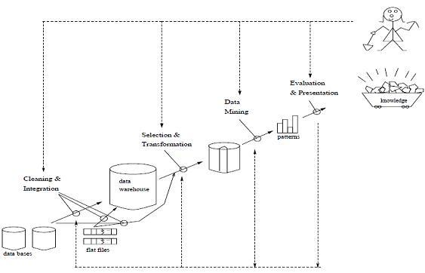

The proposed methodology of our paper is to
1. Make the Police functioning citizen friendly and more transparent by automating the functioning of Police Departments.
2. Improve delivery of citizen-centric services through effective
3. Provide the Investigating Officers of the Civil Police with tools, technology and information to facilitate investigation of crime and detection of criminals.
4. Improve Police functioning in various other areas such as Law and Order, Traffic
Management etc.
5. Facilitate Interaction and sharing of Information among Police Departments, Districts,
State/UT headquarters and other Police Agencies
6. Keep track of the progress of Cases
7. Reduce manual and redundant Records keeping

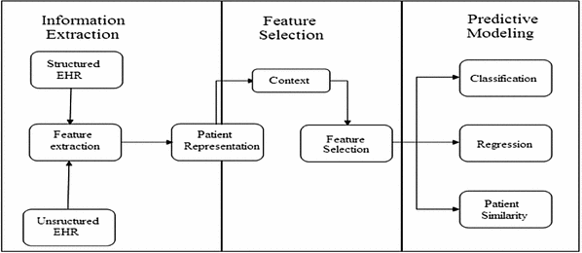

7. Flowchart
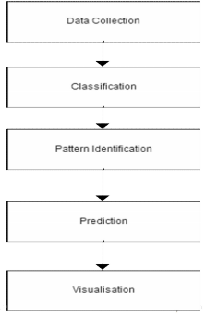

8. Implementation/methodology
This paper implements Day by day the crime rate is increasing considerably.Crime cannot be predicted since it is neither systematic nor random. Also the modern technologies and hi-tech methods help criminals in achieving their misdeeds. According to Crime Records Bureau crimes like India have
been decreased while crimes like murder, sex abuse, gang rape
etc have been increased. So for building such a powerful crime
analytics tool we have to collect crime records and evaluate it.
1.) Increase in crime information that has to be stored and
analyzed.
2.) Analysis of data is difficult since data is incomplete
and inconsistent.
3.) Limitation in getting crime data records from Law
Enforcement department.
4.) Accuracy of the program depends on accuracy of the
training set.

There are steps in doing Crime Analysis:
1) Data Collection
2) Preprocessing
3) Classification
4) Pattern Identification
5) Prediction
6) Visualization

8.1{A} DataSet VISUALIZATION
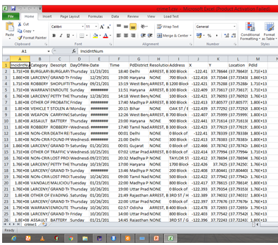

{B} Explanation of the dataset
This dataset contains the following columns. We will be dropping some columns, rename few, and add few extra columns that will help in our analysis.
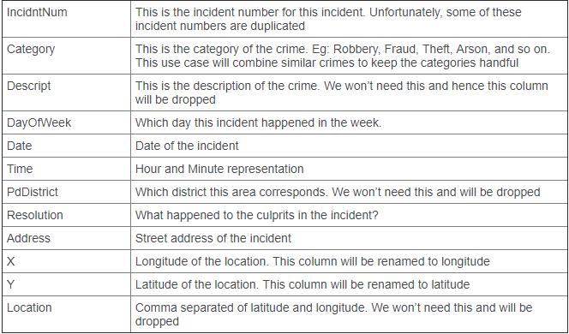

9. Accuracy for the dataset
mmetric is a predefine function we use that function for computing classification error metrics

mmetric(testD$PdDistrict, e1071prediction, c("ACC","PRECISION","TPR","F1"))
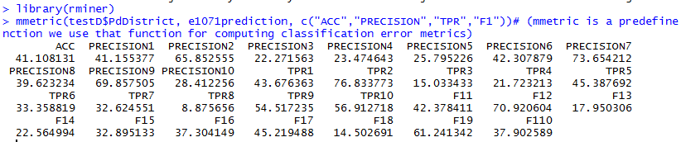
Summary of the dataset will provide aggregate details of each field based on their data type

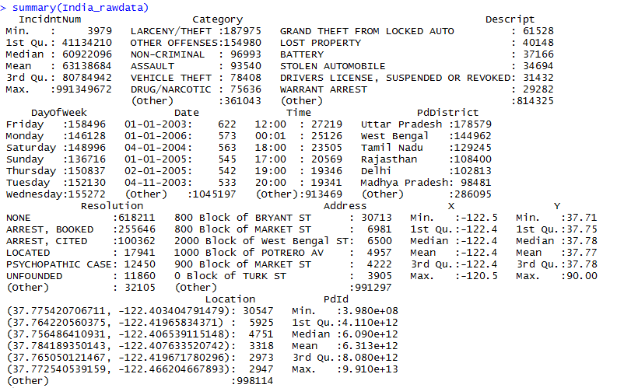

10.Framing the rules to frame a table
There are 37 crime categories but it is very evident that some categories can be grouped together to keep the factorials small for easy analysis. For example: Missing Person and Kidnapping can be grouped together as Kidnapping. We will perform ifelse condition and change to a specific category type if a set of categories are of similar types.

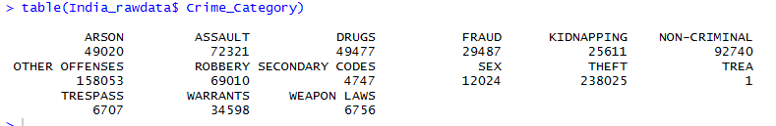

10 Plotting Of Graph Of The Dataset

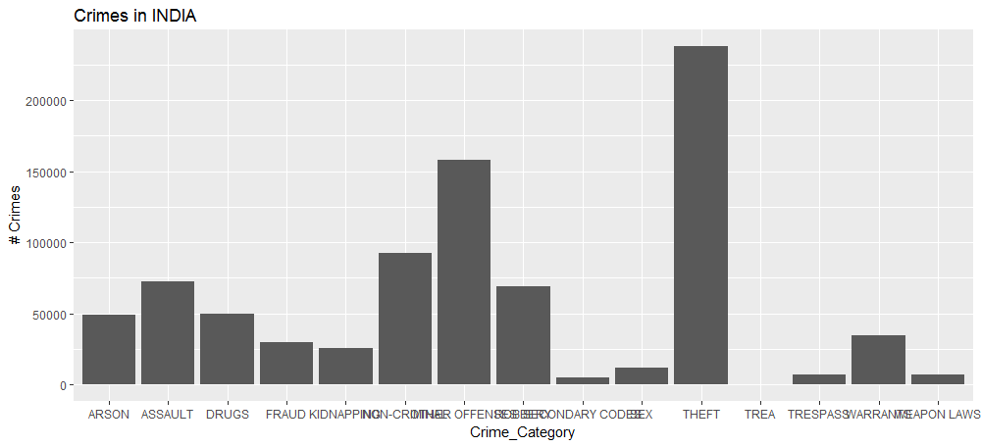

Heat Map of Crime Incidents by Time of the Day

Aggregate the Crime Category by different time buckets
incidents_by_time <-aggregate(India_rawdata$Crime_Category, by=list(India_rawdata$Crime_Category, India_rawdata$Incident_Time_Tag), FUN = length)

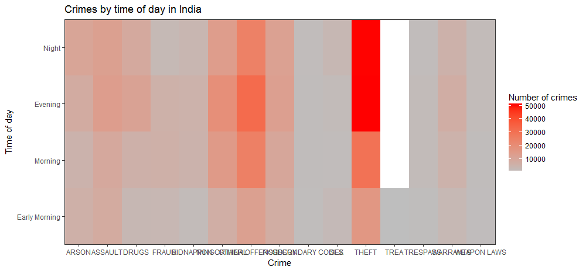

Map of Crime Incidents by Day of the Week:
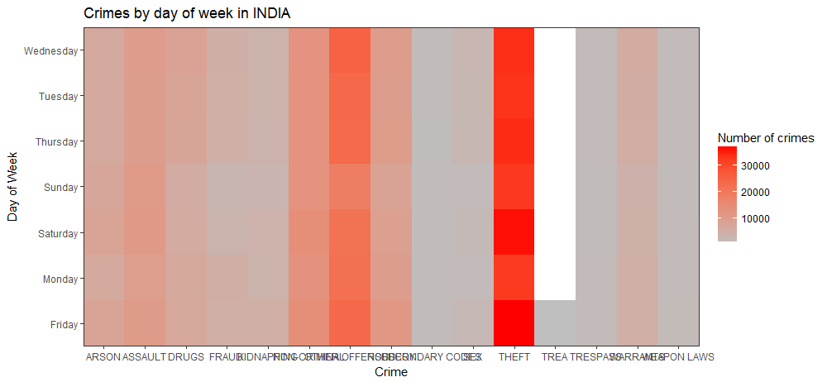

Heat Map of Crime Incidents by Month of the Year

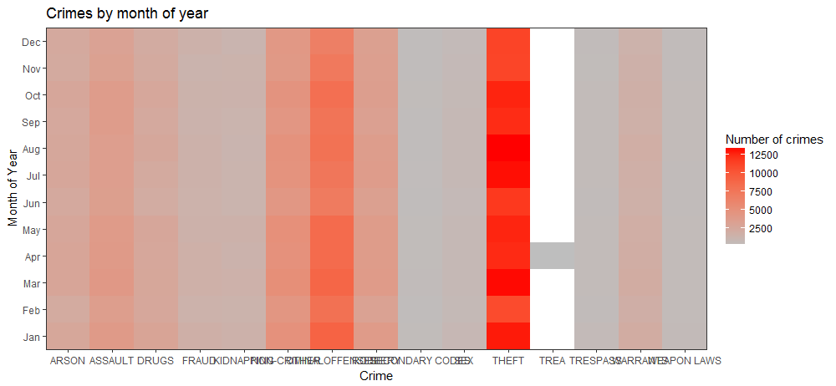

11. Results & Discussion
1) We can concentrate more on crimes like crimes to get more details related
to it like crime location, time, date, crime type(which type of snatching),
victim and offender names etc. Currently we are getting crime details like:
a.) Name of person(victims, offenders)
b.) Location
c.) Organization
d.) Type of crime( whether murder, robbery)
e.) Subcategories of crime type( for snatching there are other categories like chain snatching, purse snatching etc)
f.) Type of vehicle offender used.
g.) Whether any weapons used.
h.) Time of incident
i.) Date
j.) Incident summary
11) Criminal groups involved

12. Conclusion
It has been a protracted and useful exercise till now. We learnt how topull information specifically from web, handle, clean, and process wrongdoing information, use geocoded data through shape records, recover concealed data through perceptions, make new factors from constrained information, fabricate a prescient motor for wrongdoing, and test how great it is.The existing characterization calculations for example, Random backwoods and id3 utilized for the compelling characterization on wrongdoing dataset .I intended to present another grouping calculation called Fuzzy control based classifier for the powerful grouping. There are still a few issues that we have to deliver identified with sending, confinement, and upgrades. The model we manufactured predicts the normal number of wrongdoings in each beat in the nation of India for every day. The reason behind building the model was to construct an asset that would help law authorization offices convey their assets proactively and productively. In domain of this, one way the model could be sent is by utilizing shading coded maps recognizing the wrongdoing problem areas in the nation for a specific day. The wrongdoing problem areas would then be able to be regulated successfully by utilizing watching groups.

13. References
[1] Han Liu1 and Mihaela Cocea2 1School of Computer Science and Informatics, Cardiff University Queens Buildings, 5 The Parade, Cardiff, United Kingdom
CF24 3AA 2School of Computing, University of Portsmouth Fuzzy Rule Based Systems for Gender Classification from Blog Data. IEEE Conferences,
[2] : Syahid Anuar, Ali Selamat* and Roselina Sallehuddin Faculty of Computing, Universiti Teknologi Malaysia Hybrid Particle Swarm Optimization Feature Selection for Crime Classification. . IEEE Conferences, 2014.
[3] : Xu Yu a,, Yan Chu b, Feng Jiang a, Ying Guo a, Dunwei Gong a. SVMs Classification Based Two-side Cross Domain Collaborative Filtering by inferring
intrinsic user and item features . IEEE 24 May 2017
[4] Hugo Lewi Hammer a, Anis Yazidi a, B. John Oommen . On the classification of dynamical data streams using novel Anti-Bayesian techniques . IEEE H.L. Hammer et al. / Pattern Recognition 76 (2018) 108124
[5] T.W. Liao a,, R.J. Kuo b. discrete symbiotic organisms search algorithms for simultaneous optimization of feature subset and neighborhood size of KNN classification models . IEEE T.W. Liao a,, R.J. Kuo b
[6] Antonio-Javier Gallego, Jorge Calvo-Zaragoza, Jose J. Valero-Mas, Juan R. Rico-Juan. Clustering-based k-nearest neighbor classification for large-scale
data with neural codes representation . IEEEA.-J. Gallego et al. / Pattern Recognition 74 (2018)
[7] Hybrid Particle Swarm Optimization Feature Selection for Crime Classification Hybrid Particle Swarm Optimization Feature Selection for Crime Classification . IEEE Conferences, 2015.

